Concept Paper:
Management Information System (MIS) for
‘Regional Infrastructure Fund – II in Khyber Pakhtunkhwa for
“RESILIENT RESOURCE MANAGEMENT IN CITIES
(RRMIC)”
1. Introduction
The "Management Information System (MIS)" for the Regional Infrastructure Fund – II (RIF-II) aims to enhance the implementation, monitoring, and evaluation of resilient resource management initiatives in Dera Ismail Khan and Bannu districts.
This initiative, part of the Resilient Resource Management in Cities (RRMIC) project, is funded by KfW and the Government of Khyber Pakhtunkhwa. By centralizing operational data, the MIS will serve as a powerful tool for decision-making, resource optimization, and ensuring transparency across stakeholders.
2. Background
RIF-II addresses urban challenges related to water supply, wastewater management, and solid waste management. These sectors face significant resource and operational constraints, compounded by rapid urbanization and climate-related risks. The MIS is critical to supporting the project’s objectives by providing a centralized platform to integrate and analyze data, ensure effective resource utilization, and foster citizen engagement.
Aligned with Sustainable Development Goal (SDG) 11—"Sustainable Cities and Communities"—this MIS will bolster infrastructure development and improve service delivery in selected tehsil towns.
2. Process Flowchart
MIS Development Process Flowchart
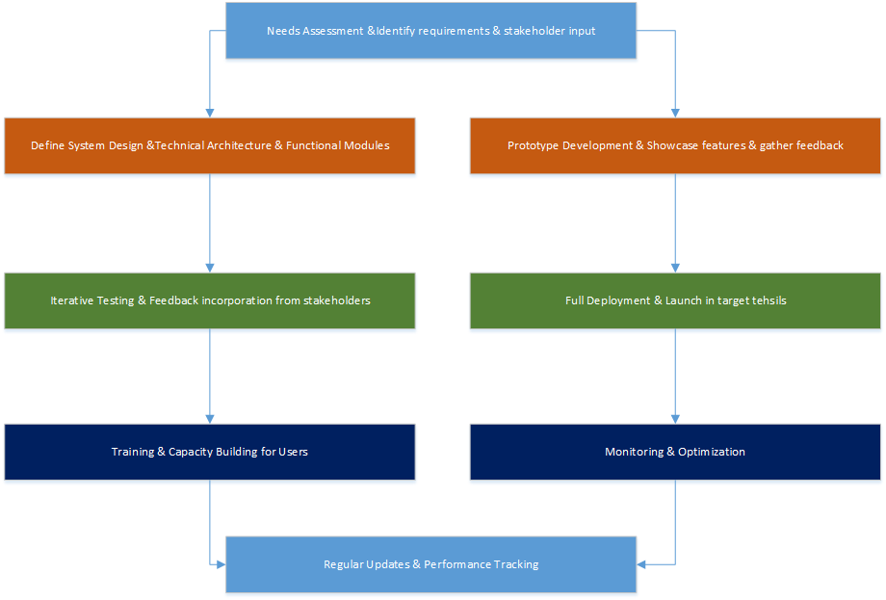

3. Objectives of the MIS
The MIS aims to:
- Consolidate Data: Integrate information from surveys, Training data from social team, GIS, operational data, and infrastructure projects.
- Facilitate Monitoring and Reporting: Enable real-time tracking of project activities, infrastructure performance, and key indicators.
- Support Decision-Making: Provide actionable insights for resource allocation, planning, and policymaking.
- Enhance Citizen Participation: Include tools for public feedback, awareness campaigns, and progress updates.
- Promote Scalability: Allow expansion to additional districts or initiatives in Khyber Pakhtunkhwa.

4. Scope of the MIS
4.1. Data Integration and Analytics
- Aggregate baseline surveys, Training data, GIS mappings, and infrastructure-related data.
- Monitor water distribution, wastewater treatment, and waste management operations.
4.2. Core Features
- Monitoring and Evaluation: Real-time dashboards, progress tracking, and reporting aligned with project KPIs.
- GIS-Based Mapping: Spatial planning tools for infrastructure placement and service coverage visualization.
- Citizen Engagement: Web and mobile portals for feedback, suggestions, and updates.
- Training and Capacity Building: Modules for stakeholders, including government staff, CSOs, and community representatives.
4.3. Beneficiaries and Stakeholders
- Provincial Authorities: Planning and Development Department (P&DD) and Urban Policy Unit (UPU).
- District-Level Bodies: Public Health Engineering Department (PHED), Tehsil Municipal Administrations (TMAs).
- Communities: Local populations in Dera Ismail Khan and Bannu districts.
- Development Partners: KfW, NGOs, and other supporting organizations.
5. Benefits of the MIS
- Improved Efficiency: Streamlined workflows through automated data collection and analysis.
- Transparency: Enhanced accountability via real-time updates and public dashboards.
- Community Empowerment: Increased public involvement in planning and project oversight.
- Sustainability: Data-driven resource management to minimize environmental impacts.
- Scalability: Replicable framework for similar projects in other districts.

6. Implementation Plan
6.1. Development Phases
- Needs Assessment: Engage stakeholders to outline data requirements and system architecture.
- Design and Prototyping: Create a blueprint and initial system prototype for feedback.
- Development and Testing: Build the MIS with iterative testing to ensure functionality.
- Deployment and Training: Roll out the system and train users at provincial and district levels.
- Monitoring and Upgrades: Evaluate system performance and implement periodic updates.
6.2. Technology Stack
- Database: Cloud-based solutions (e.g.SQL Server).
- GIS Tools: QGIS for mapping and spatial data analysis.
- Analytics and Visualization: Power BI, Power Query for cleansing data for reporting.
- User Interfaces: Web-based dashboards and mobile-friendly applications (asp.net & C#).
8. Risks and Mitigation
- Data Availability: Standardize data collection protocols to ensure consistency.
- Technical Challenges: Use robust and scalable technology to address potential system failures.
- User Adoption: Conduct comprehensive training and include user-friendly interfaces.
9. Conclusion
The Management Information System for RIF-II is poised to transform urban resource management in Khyber Pakhtunkhwa. By integrating advanced technologies with participatory governance, the MIS will enhance operational efficiency, foster transparency, and empower communities, ensuring the project's success and scalability to other regions.

